Download and set up CARLA 0.9.15.
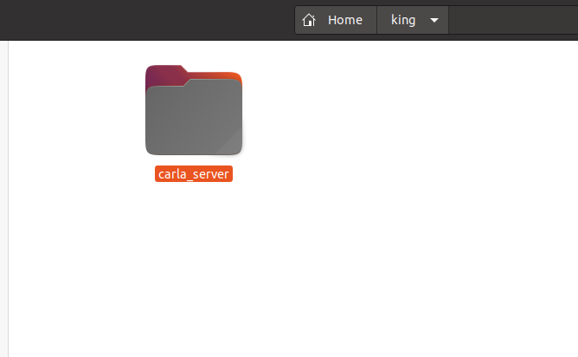

Clone the repository King-Replay from https://github.com/SanjeethaPennada/King-Replay. Extract all the files into our folder (where carla is installed) as shown below. Now we have all the required files to replay king with modifications.

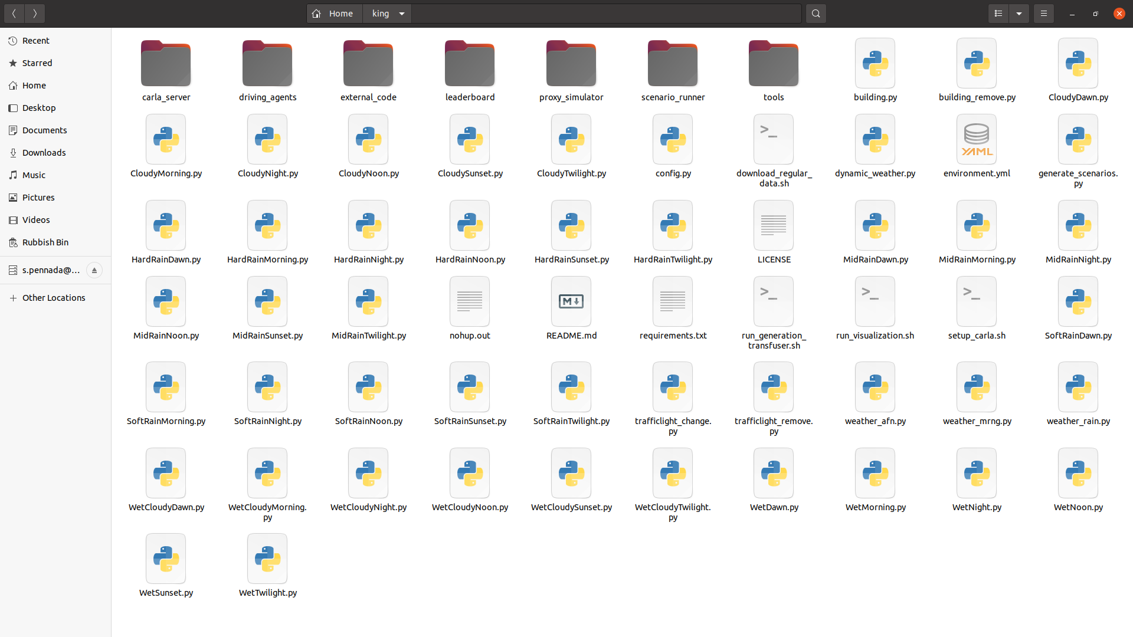
Now install all the required libraries listed in requirements.txt. Also verify the hardware and software requirements listed in README.md file.

Install drivers and reboot. If the appropriate version of the driver is already installed (Check with the command nvidia-smi), if installed should appear as below and
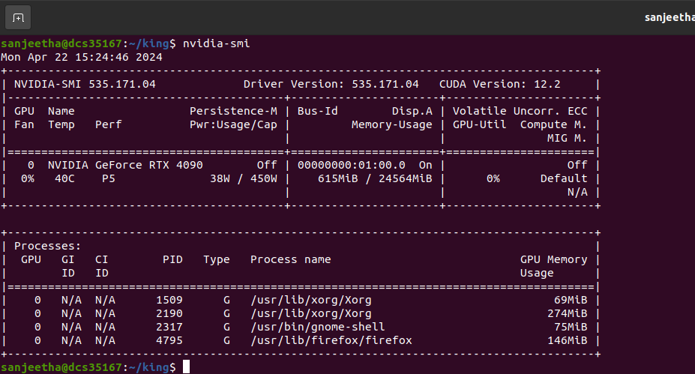

you can skip this step or else install them using below commands:
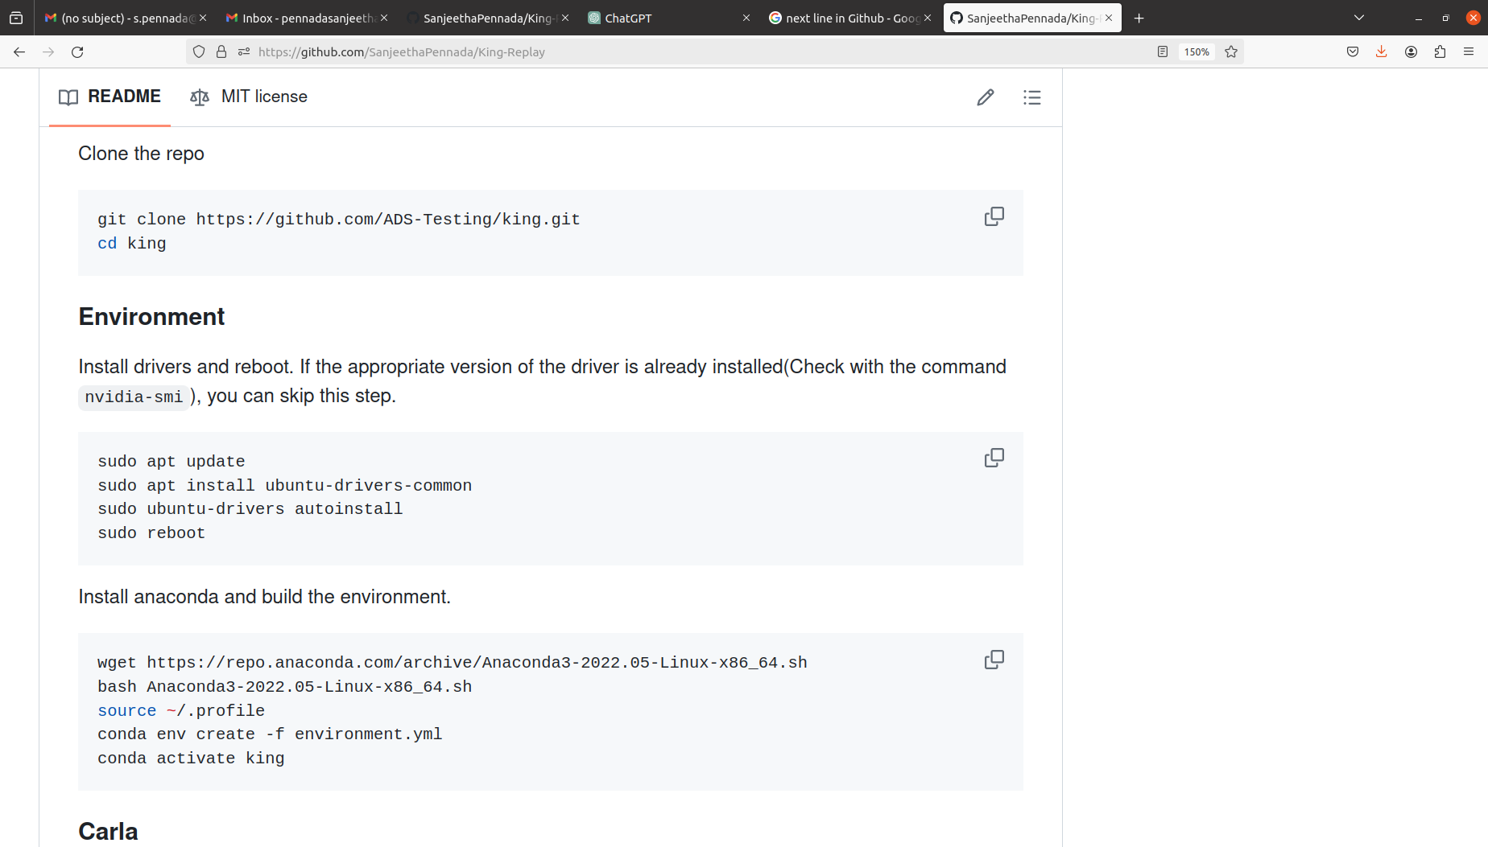

Install anaconda and build the environment.

Check tworking of CARLA simulator.
Go to carla_server folder – right click and select open in terminal – enter conda acticvate king – and next enter ./CarlaUE4.sh and CARLA is loaded successfully as shown below.
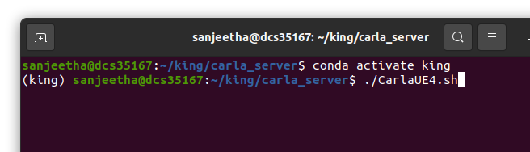
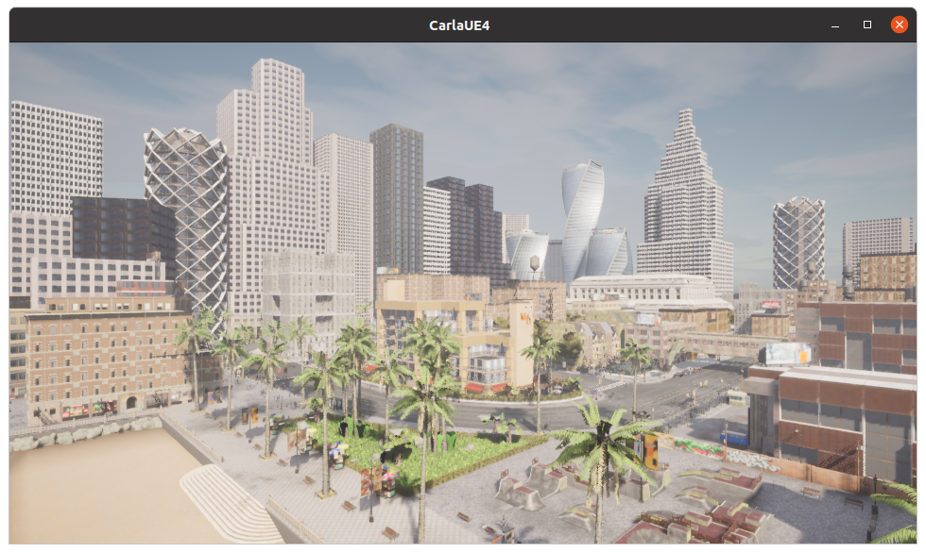

To generate scenarios for Transfuser, you need to download the model weights:
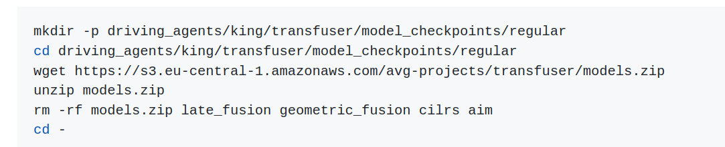

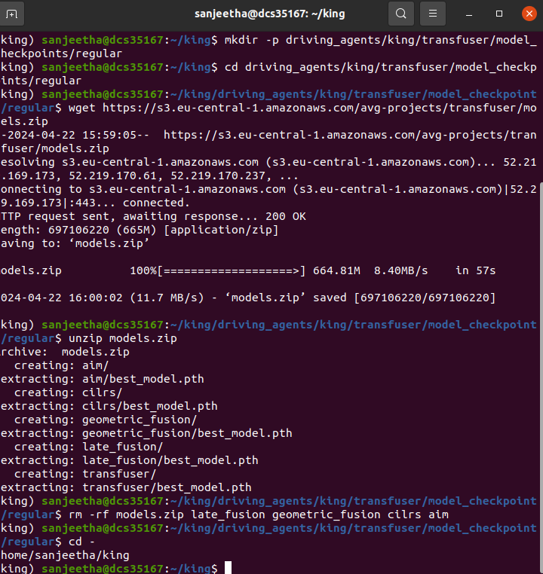

TransFuser generation and Scenario Replay
For Transfuser generation using both gradient paths, open run_generation_transfuser.sh file and change number of agents to 1 or 2 or 4 (default = 4 agents)
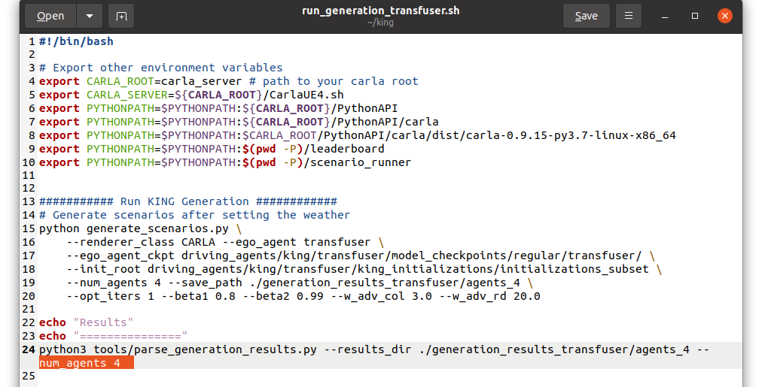
and run:
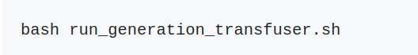

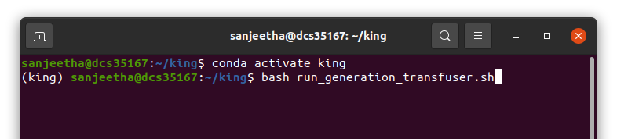

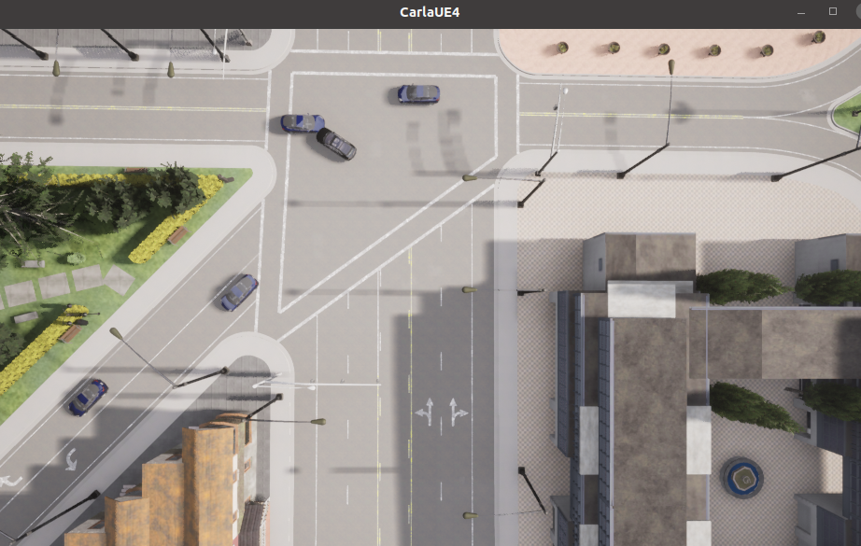

Collisions are also detected in the scenario using Collision rate
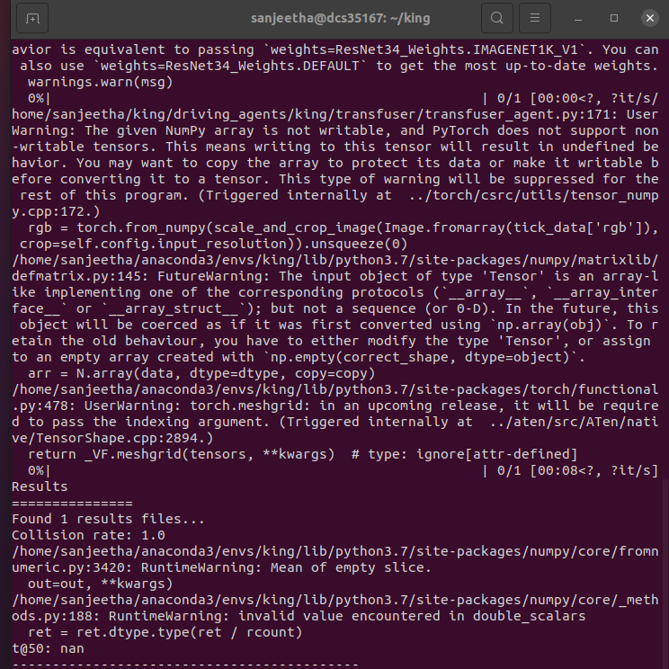
In order to visualize this scenario, run:
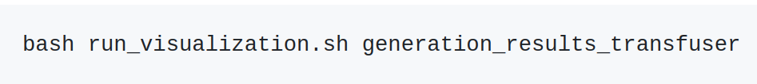
Getting results: Now you can find a new folder named generation_results_transfuser

generation_results_transfuser/
└── agents_4
├── RouteScenario_136_to_136
│ ├── RouteScenario_136_iter_0.gif
│ ├── results.json
│ └── scenario_records.json

...
├── opt.pkl
└── opt.txt
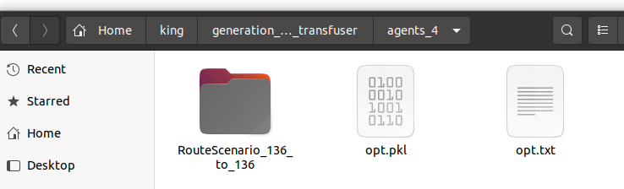

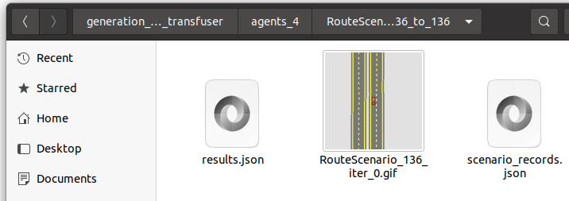

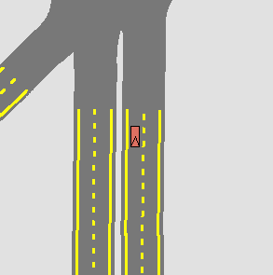

RouteScenario_136_iter_0.gif

Open opt.txt to view information about scenario generated.
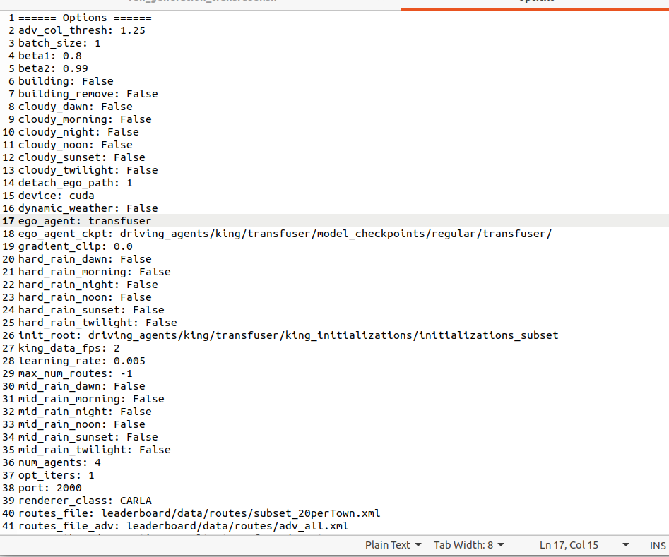

Replaying Scenario with modifications:

Open run_generation_transfuser.sh file, and type below arguments to tailor the environment. Add arguments as indicated in generate_scenarios.py file. For example if you would like to
a) change weather to CloudyNight: Use argument –cloudy_night in run_generation_transfuser.sh, spin up CARLA and open terminal to run bash run_generation_transfuser.sh
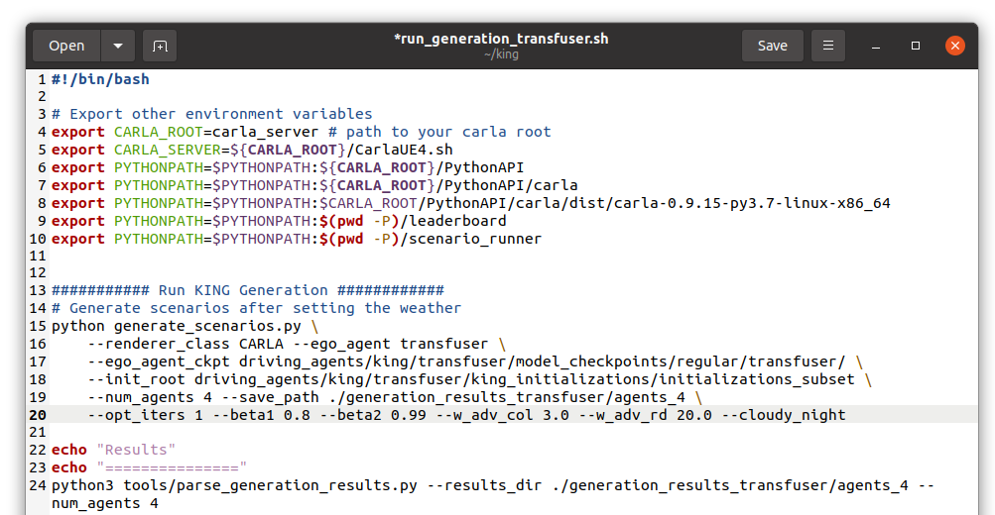

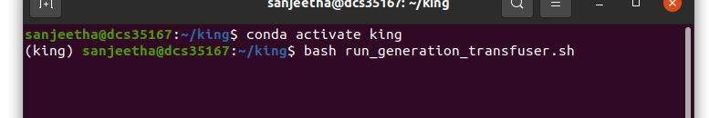

The scenario is generated with cloudy_night settings.
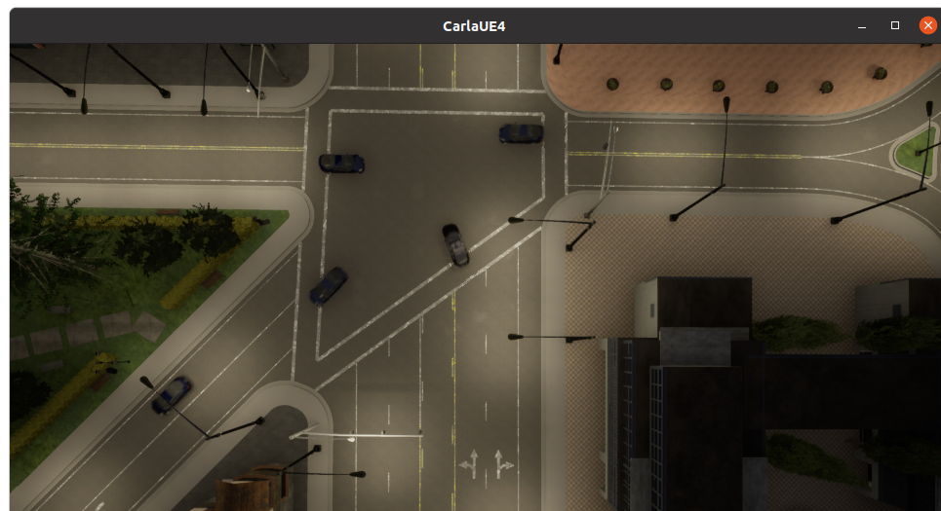
Similarly various arguments can be included in generate_scenarios.py to replay the selected route/scenario with modifications.
b) Toggling off all the buildings in a scenario using –building argument in generate_scenarios.py and run:

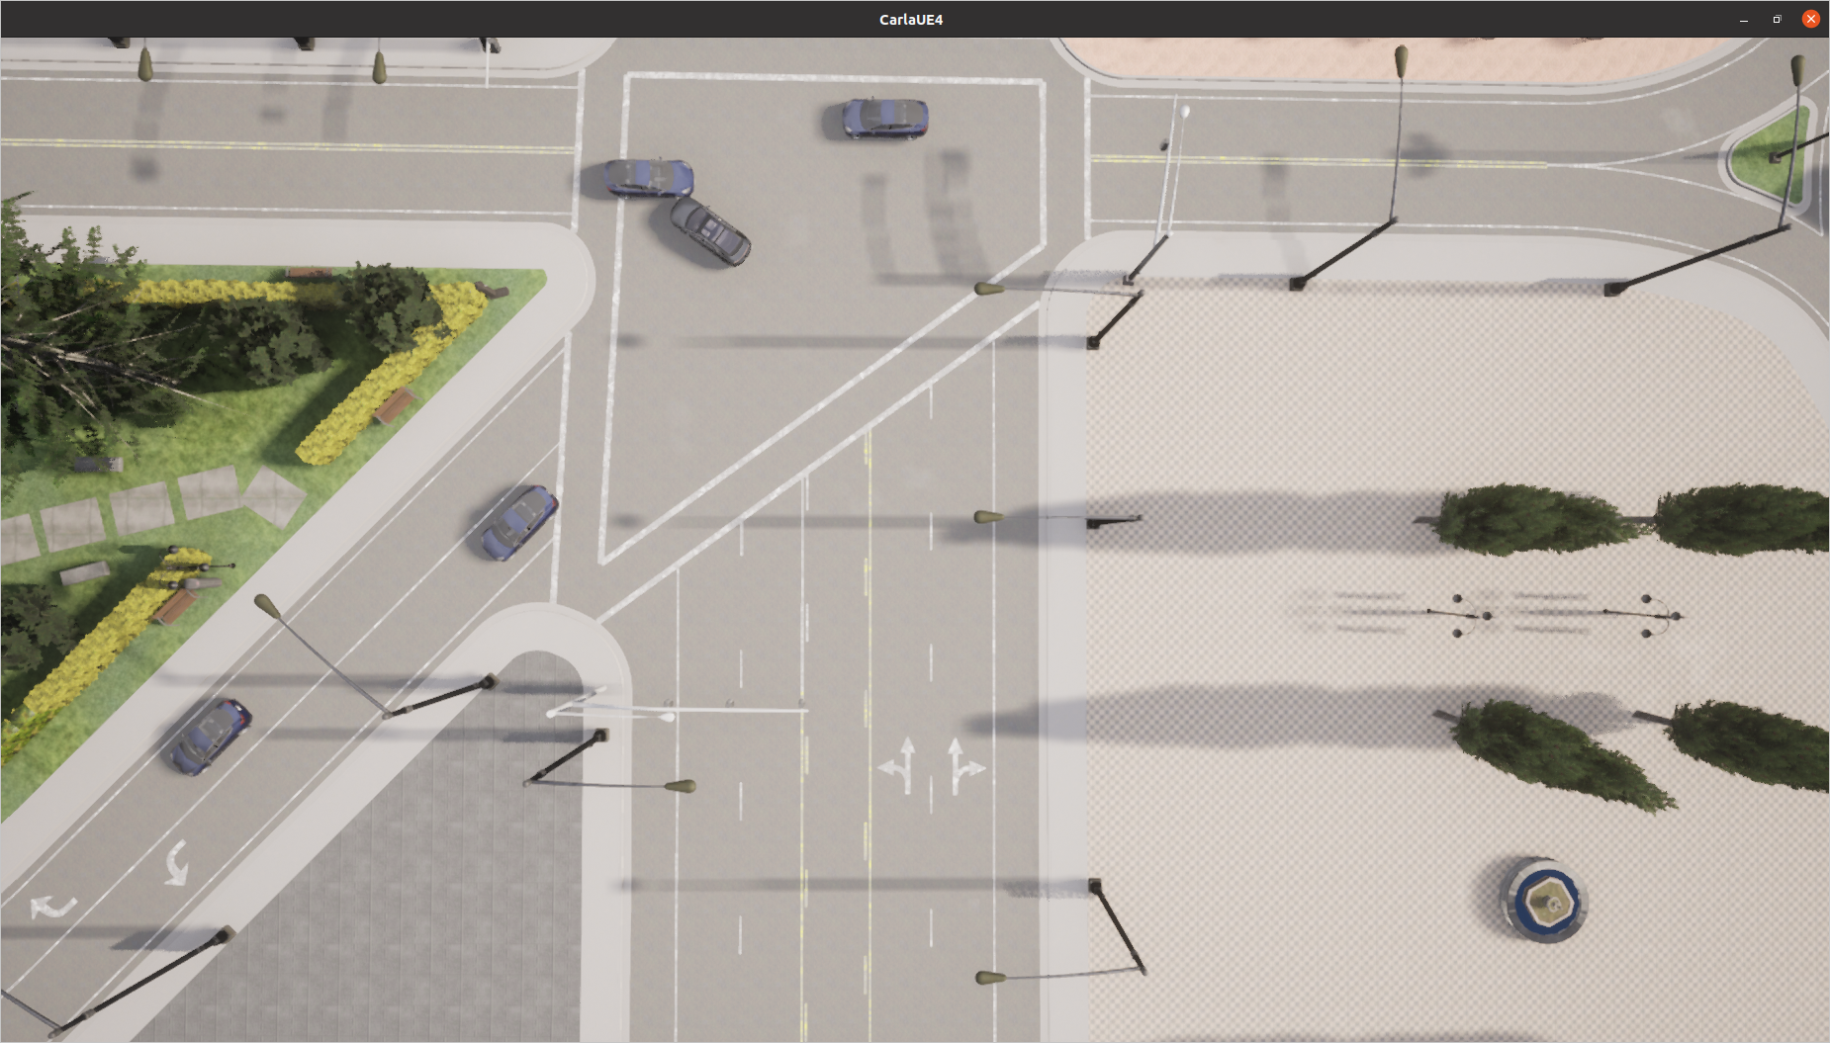

c) If you want to toggle specific building in the scenario use argument –building_remove in generate_scenarios.py, and select the building you want to remove by making corresponding changes to building_remove.py file
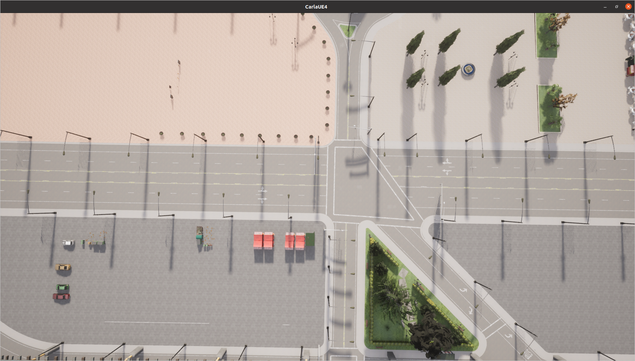
TOP LEFT
BOTTOM LEFT
TOP RIGHT
BOTTOM RIGHT
# Define your location (replace these coordinates with your actual location)
ocation = carla.Location(x=-150.0, y=30.0, z=50.0) # to remove top left building
location = carla.Location(x=-150.0, y=70.0, z=50.0) # to remove bottom left building
location = carla.Location(x=-80.0, y=100.0, z=100.0) # to remove top right building
location = carla.Location(x=-80.0, y=180.0, z=120.0) # to remove bottom right building

# Define the radius within which to search for buildings
radius = 100.0 #to remove top left building
radius = 100.0 # to remove bottom left building
radius = 150.0 # to remove top right building
radius = 200.0 # to remove bottom right building

# Collect the IDs of the first n buildings
first_n_building_ids = [building.id for building in building_objects[:60]] # to remove top left building
first_n_building_ids = [building.id for building in building_objects[:100]] #to remove bottom left building
first_n_building_ids = [building.id for building in building_objects[:10]] # to remove top right building
first_n_building_ids = [building.id for building in building_objects[:45]] # to remove bottom right building
and run:

